|  |  |
| --- | --- |
| **Team ID** | PNT2022TMID39959 |
| **Project Name** | Smart Fashion Recommender |

**Flask Installation**

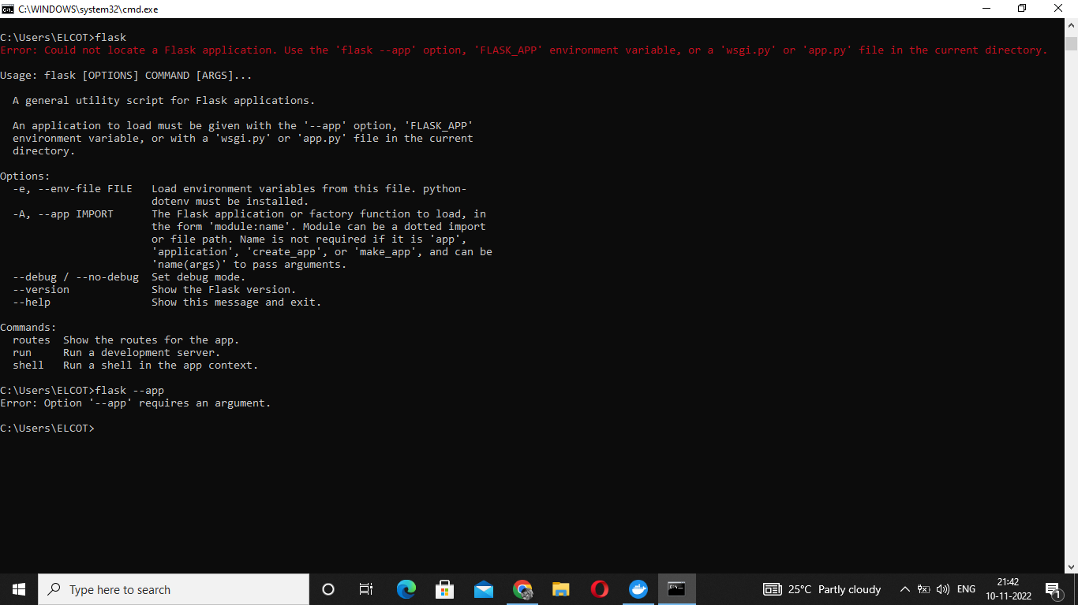

**Sample flask program with output:**

